After running the first statement of T2.

This is what happens to T1.

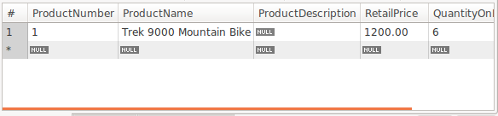

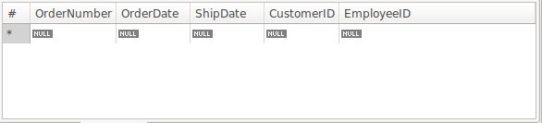

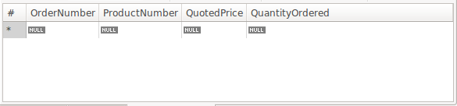

After running the rest of T2.

T1 results.

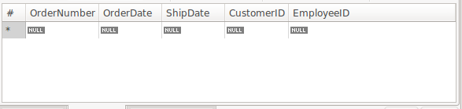

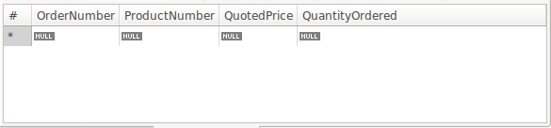

Commit T2.

T1 results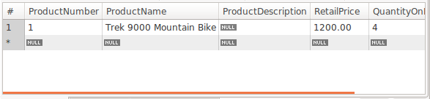

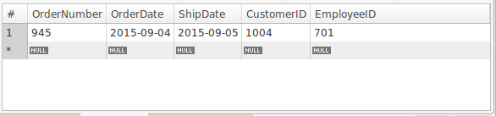

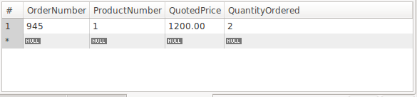

Commit T1

T1 results







Read committed is a lower isolation level compared to repeatable read. Unlike repeatable read, it is possible to get nonrepeatable read. The changes could be observed in T1 right after committing the changes in T2. Lost updates are a problem that occurs when two transactions that access the same database items have their operations interleaved in a way that makes the value of some database items incorrect. For example, T1 and T2 are trying to update the same database item. The final value of the item X is incorrect because T2 reads the value of X before T1 changes (commit) it in the database, hence the updated value resulting from T1 is lost.

|  |  |
| --- | --- |
| T1 | T2 |
| SELECT * FROM Products WHERE ProductNumber = 1; |  |
|  | SELECT * FROM Products WHERE ProductNumber = 1; |
|  | UPDATE Products SET QuantityOnHand = QuantityOnHand + 2 WHERE ProductNumber=1; |
| UPDATE Products SET QuantityOnHand = QuantityOnHand – 2 WHERE ProductNumber=1; |  |
| Commit;  /*this item has an incorrect value because its update by T1 is lost (overwritten)*/ |  |
|  | Commit; |